

Foundations of Programming

Assignment No.: 22
PROBLEM STATEMENT: Write a menu driven program in C to perform various string operations using in-built functions.

OBJECTIVE:

- To understand the concept of strings in the C programming language.
- To learn how to use built-in string functions for string manipulation.
- To perform operations such as length calculation, copying, concatenation, comparison, and reversal using menu options.
.

THEORY:
In the C programming language, a string is a sequence of characters terminated by a null character ('\0'). Strings are stored in character arrays and manipulated using functions available in the string.h header file.
Common built-in string functions include strlen() for finding the length of a string, strcpy() for copying one string to another, strcat() for concatenating two strings, and strcmp() for comparing two strings.
A menu driven program allows the user to select different operations from a list of options. Based on the user’s choice, the corresponding string function is executed. This approach makes the program interactive and easy to use.

PLATFORM: Linux

INPUT: Two strings entered by the user.
CODE:
#include <stdio.h>
#include <string.h>

int main() {
char str1[100], str2[100], temp[100];
int choice;

printf("Enter first string: ");
scanf("%s", str1);

printf("Enter second string: ");
scanf("%s", str2);

do {
printf("\n--- MENU ---\n");
printf("1. Length of string\n");
printf("2. Copy string\n");
printf("3. Concatenate strings\n");
printf("4. Compare strings\n");
printf("5. Reverse string\n");
printf("6. Exit\n");

printf("Enter your choice: ");
scanf("%d", &choice);

switch (choice) {
case 1:
printf("Length of str1: %lu\n", strlen(str1));
break;

case 2:
strcpy(temp, str1);
printf("Copied string: %s\n", temp);
break;

case 3:
strcpy(temp, str1);
strcat(temp, str2);
printf("Concatenated string: %s\n", temp);
break;

case 4:
if (strcmp(str1, str2) == 0)
printf("Strings are equal\n");
else
printf("Strings are not equal\n");
break;

case 5:
strcpy(temp, str1);
strrev(temp); // may not work in some compilers
printf("Reversed string: %s\n", temp);
break;

case 6:
printf("Exiting...\n");
break;

default:
printf("Invalid choice\n");
}

} while (choice != 6);

return 0;
}

OUTPUT: Displays results of different string operations such as length, copy, concatenation, and comparison.

SAMPLE INPUT:
Enter first string: Hello
Enter second string: World
Choice: 3

SAMPLE OUTPUT:
Concatenated string: HelloWorld
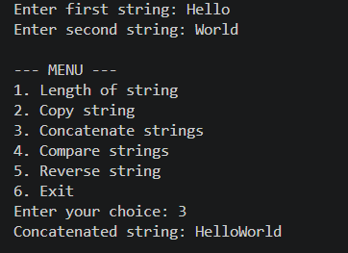
CONCLUSION: Thus, the C program successfully demonstrates different string operations using built-in functions through a menu driven approach, making the program interactive and easy to use.

FAQs:
- What are built-in string functions in C and why are they used?
- What is the purpose of the string.h header file in C programs?
- How does a menu driven program improve user interaction in programming?

